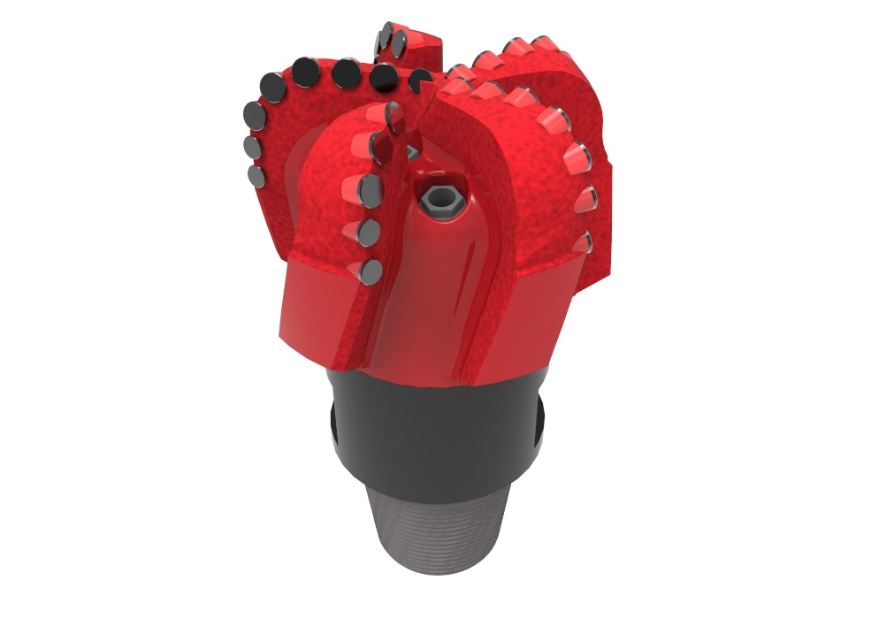
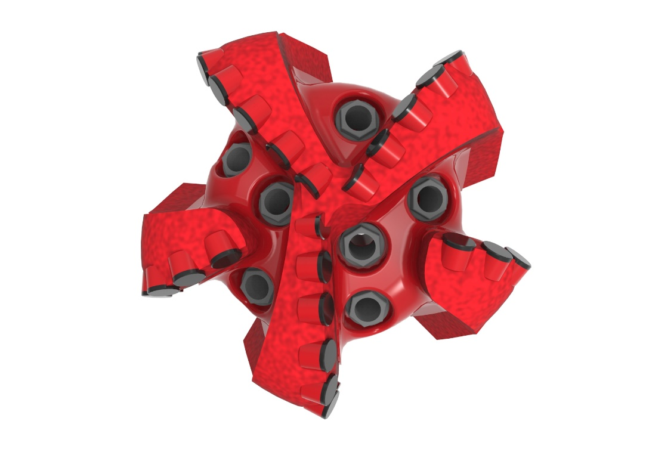

Drill Bit Specifications:
Cutter Size (Primary, Sec) | 5/8”, 1/2”
Cutter Count (Total, Gage) | 32,9
Blade Count | 5
Gage Length (Inches) | 2.50
Nozzle Count (Primary, Sec.) | 7
Nozzle Series (Primary, Sec.) | 60
JSA (Sq. Inches) | 18.40
Max. TFA (Sq. Inches) | 2.60
Operating Parameters:
Max. Weight on Bit (1,000 Lbs.) | 60
Make-up Torque (ft/lbs) | 17,399
Nominal Dimensions:
Overall Length (Inches) | 14.375
Make Up Length (Inches) | 10.25
Bit Breaker | SKB-21010
Connection | Ø4-1/2" API Reg.
Approx. Weight (Lbs.) | 120



Standard Features:

- Premium grade cutters maximize ROP and Life
- Nozzle configuration and large open face volume optimize blade cleaning and cuttings removal

516-SR7 Nomenclature Explained:

• | 5 | = | Number of blades
• | 16 | = | Primary Cutter Size (16mm)
• | SR | = | Single Row of Cutters
• | 7 | = | Number of Nozzles

